Data Structures & Algorithms
Exercise 2: Exercise 2: E-commerce Platform Search Function
Code:
public class Main {
class Product {
int id;
String name;
String category;

Product(int id, String name, String category) {
this.id = id;
this.name = name;
this.category = category;
}

public void printDetails() {
System.out.println(id);
System.out.println(name);
System.out.println(category);
}
}

void searchByName(Product[] products, String name) {
boolean found = false;
for (Product p : products) {
if (p.name.equalsIgnoreCase(name)) {
p.printDetails();
found = true;
break;
}
}
}

void example() {
Product[] items = {
new Product(1, "Laptop", "Electronics"),
new Product(2, "Mobile", "Electronics"),
new Product(3, "Shoes", "Fashion")
};

searchByName(items, "Mobile");
}

public static void main(String[] args) {
new Main().example();
}
}

Output:
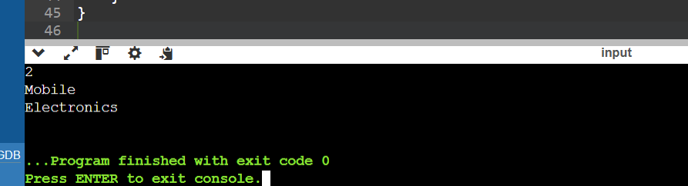

Exercise 7: Exercise 7: Financial Forecasting
Code:

public class Main {
int calculate(int amount, int rate, int years) {
if (years == 0) {
return amount;
}
return calculate(amount, rate, years - 1) * (1 + rate);
}
void run() {
int Amount = 1000;
int Rate = 2;
int Years = 4;

int result = calculate(Amount, Rate, Years);

System.out.println("No of years:" + Years);
System.out.println("Results: Rs."+result);
}

public static void main(String[] args) {
new Main().run();
}
}

Output:
